What Blockbuster’s Demise Tells Us About Good Business
  - Authors: Nick Acre and Francois Zucco

Table of Contents
1.1 Introduction 1
1.2 Background 2
2.1 An Exploitative Business Model 2
2.1.1 Attempted Reforms 3
2.1.2 Resistance To Change 4
2.1.3 Dissonance With Shareholders 5
2.1.4 Pushback From Within 6
2.2 Results 6
3.1 Discussion 7
3.2 Recommendations 8
4.1 References 8

1.1 Introduction
At its height as the leader of the video-rental market in 2004, Blockbuster operated over 9,000 stores and employed over 80,000 people globally. In the wake of subscription based video and the rise of Netflix, Blockbuster declared bankruptcy in 2010. Today it survives as one store in Bend, Oregon.
The Canadian Radio-Television and Telecommunications Commission is an independent, public administrative tribunal which regulates and supervises broadcasting and telecommunications in Canada. Its stated mission includes:
- “Ensuring Canadians can connect to quality and innovative communication services at affordable prices.”
- “To ensure that Canadians have access to compelling creative content from diverse sources and on a variety of platforms.”
Disruptive innovation can compromise both of these objectives, and so can failure to correctly react at an organizational level to disruptive innovation.
To this end, the CRTC has commissioned this study to inform Canadian broadcasters and telecommunications companies on the importance of well-managed change and long term planning.

1.2 Background
The first Blockbuster store was opened in Dallas, Texas, in 1985 by David Cook, a businessman in the oil and gas industry who wanted to get into the video market. Blockbuster grew to become the leader of video rentals in the United States. In 1994, Viacom bought the company for $8.4 million.
John Antioco came on as CEO in 1997, and helped to grow Blockbuster into its greatest size. He employed a successful revenue sharing model with movie studios, and began an initiative that guaranteed that the supply of popular movies would always meet demand. In 2004, Blockbuster reported an annual revenue of $6 billion.
At the same time, Netflix, Blockbuster’s would-be competitor, was slowly expanding with its own subscription based, video-by-mail model. Reed Hastings founded the company in 1997, and three years later offered to sell it to Blockbuster for $50 million. This offer was rejected by Antioco, on the reasoning that Netflix’s market was too niche, and that it was consistently losing money.
Other important competitors to Blockbuster were Redbox and Walmart. Redbox deployed unmanned kiosks from which customers could rent DVDs. This allowed it to be distributed in huge quantities across the United States at minimal cost. Walmart was a major retailer, quickly growing to take its modern place as the world’s largest business. Among a plethora of other items, these stores sold VHSs and, later, DVDs, making it a major competitor with Blockbuster.

2.1 An Exploitative Business Model
Blockbuster’s success was undeniable, but its foundation was brittle. Throughout the company’s lifetime, movie rentals formed the majority of Blockbuster’s revenue, and some movies were in greater demand than others. Maximizing profits meant maximizing the number of times a single movie could be rented. The key bottleneck for this was ironically the customers themselves, who tended to want to hold on to movies at their leisure. A strong incentive was needed to ensure customers returned their movies as quickly as possible, and Blockbuster provided this incentive through late-fees.
While this began as a sound strategy to keep movies coming and going from Blockbuster, it also turned into a new source of revenue. Late-fees could double or even triple the original cost of a rental, and formed a cornerstone of Blockbuster’s income. In 2000, Blockbuster earned $800 million in late-fees, 16% of their revenue that year, while some analysts speculated that at its height Blockbuster made 70% of their annual revenue from late fees alone. While this looked good on balance sheets and pleased shareholders, customers were effectively being punished. Pressured to return their movies before they might be ready, and charged a high price when they failed to do so, customers abided Blockbuster’s model for as long as there were no significant competitors.
Netflix’s service may have lacked brick-and-mortar stores which provided browsing and a superior customer-experience, but it had a payment system that was fundamentally more appealing to consumers. Charging a flat fee for subscription to their service, Netflix mailed their movies directly to customers and allowed them to keep several at a time without incurring late-fees. Whereas Blockbuster was constantly vying to get their most popular movies returned so they could rent them again to someone else, Netflix approached the demand for new releases in an innovative way: rather than create a system to penalize late returns, they created one for recommendations of older movies for subscribers based on previous movies they’d rented. This system was so effective, it decreased demand for new releases to 20% of the total demand, as opposed to 70% for conventional video rental services. Both businesses tackled the same problem: one solved it by punishing customers for wanting what they wanted and the other solved it by giving those customers more things to want.
As well-entrenched a competitor as Blockbuster was, the market steadily began to show which business model consumers preferred. Though launched in 1998 and not announcing a positive fiscal year until 2003, Netflix was already proving disruptive even before they launched the streaming service with which their company would soon become synonymous. The movie rental subscription service would grow exponentially, from 300,000 subscribers in 2000 to over 7 million in 2007. In that same timeframe, Blockbuster was anything but defeated, but it was rightly concerned by the steady growth of a competitor. Netflix was on to something, and Blockbuster correctly surmised that it needed to react.

2.1.1 Attempted Reforms
In 2004, CEO John Antioco began planning two major initiatives in response to growing threats by competitors.
The prominence of subscription services forced Blockbuster to reassess its late-fee policy. To remain competitive, Antioco implemented a “No Late Fees” program starting January 2015 in select stores. It would never fully adopt the policy. Many stores experienced problems with availability of popular movies; customers would take out the in-demand DVDs for inordinate lengths of time, creating a shortage and a loss of revenue. By December of that same year, many Blockbuster stores had reinstated late-fees.
The lack of clarity on the new program ultimately led to the company being sued by New Jersey officials for false advertising. Although the late-fee had been removed, customers who kept their rented DVD or tape for a week past the due date were charged for the full sale price of the item, minus the cost of the rental. This cost was charged straight to the customer’s credit card without notification. If the customer returned the item within a month, they could get a full refund, minus a small “restocking” fee - another point of contention by the plaintiffs. Blockbuster would eventually settle by offering full refunds to affected customers. This settlement cost the company less than $1 million.
Nevertheless, shareholders calculated that the No Late Fees program lost Blockbuster $200 to $300 million dollars a year in lost profits.
Antioco’s second major initiative was Blockbuster Total Access, launched in 2006. Competing directly with Netflix, subscription-paying customers could browse the Blockbuster Online website and have DVDs mailed directly to them. Plus, subscribers would get coupons for a free rental upon returning the DVD to a Blockbuster store. Total Access operated at a loss, but was able to gain over two million subscribers by 2007. Next to Netflix’s 8.3 million subscribers, Total Access was a strong, emerging competitor. The two companies fought a legal battle over patent infringement, eventually settling in June 2007.
Antioco’s reforms might have been seen as necessary to compete, but were inarguably drastic and costly, causing upset in the upper echelons of the company.
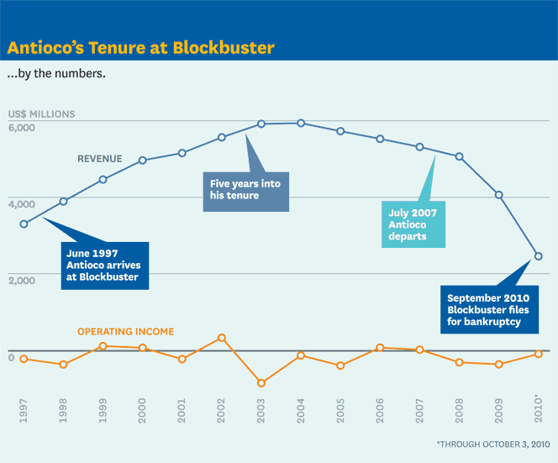
John Antioco grew Blockbuster to its greatest size. The need for reform was well-founded, but cost millions of dollars, plus Antioco’s position as CEO.
Chart Source: Harvard Business Review, April 2011

2.1.2 Resistance To Change
While there might have been a will to innovate, Blockbuster’s position of dominance in the market made it inflexible. Technology would eventually enable its competitors to bypass the rental giant.
When Antioco refused Reed Hastings’s offer to sell Netflix for $50 million, the reasoning wasn’t unsound. At that point Netflix was still only a DVD mailing service. It was a niche company with consistent operating losses and a high attrition rate. In 2000, it had only 300,000 subscribers. But Hastings had a model that appealed to consumers and Netflix quickly rose to success. It turned its first profit of $6.5 million in 2003. By 2006, Netflix counted 6.3 million subscribers and the numbers continued to soar.
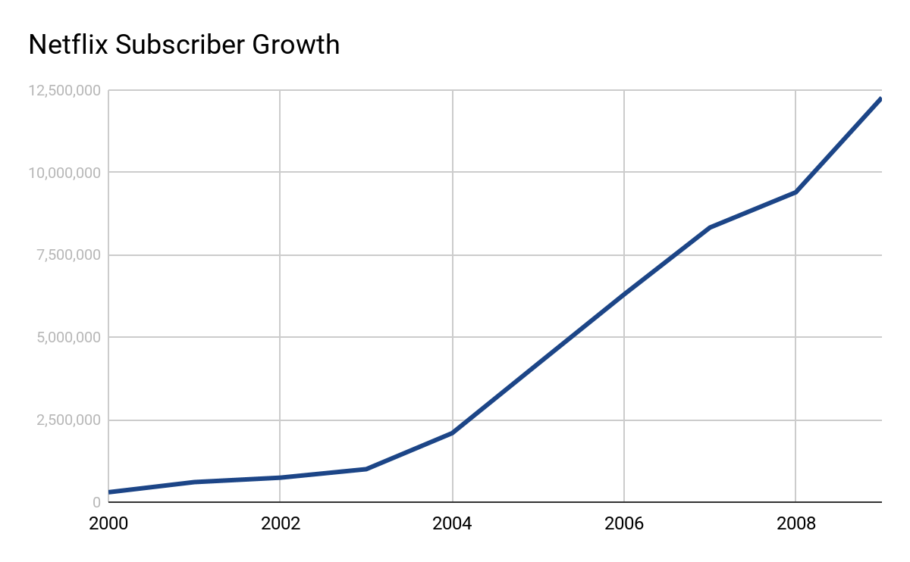
Blockbuster was slow to adopt DVD format, which had begun to be sold commercially in 1997. In 1999, 13% of Blockbuster stores were renting out DVDs. They also turned down a deal offered by Warner Bros. to exclusively rent new DVDs before they were sold to the general public, in return for 40% of rental revenues. Blockbuster reasoned that since the studios relied on them for profit, such a deal was unnecessary. Warner Bros. instead priced their DVDs low enough that mass retailers like Walmart could compete. DVD sales became hugely popular, and Walmart soon replaced Blockbuster as the studios’ main source of revenue. Blockbuster executives explained that they had not expected consumers to adopt the DVD as rapidly as they had. In 2002, DVD sales nearly doubled VHS sales. In 2003, they more than tripled. By 2006, the US market was spending $24 billion on DVD rentals and sales.
Attempts by Blockbuster to offer direct video services were never successful. In 2000, Blockbuster signed a deal with Enron to use their a fiber-optic telecommunications network to provide on-demand service. The relationship fell through a year later, shortly before Enron went bankrupt. In 2007, Blockbuster acquired Movielink in a bid to enter the online market, dominated at the time by Netflix. A year later, Movielink was shutdown. Netflix had begun its hugely successful streaming service, while Blockbuster refocused on its brick-and-mortar stores.
The stores had remained Blockbuster’s primary concentration. Their reputation was that there was a Blockbuster around the corner of every home in the US and Canada. As online and mail services took up an increasingly large portion of the rental market, Blockbuster’s thousands of stores became a disadvantage. The operating costs for the stores ate a significant portion of revenue, while services like Netflix or Redbox could compete without physical locations to maintain, and with only a fraction of the labour cost. From its peak in 2004, Blockbuster stores would continually shutter around the world, going from 5,809 American outlets to 3,090 once the company closed down.
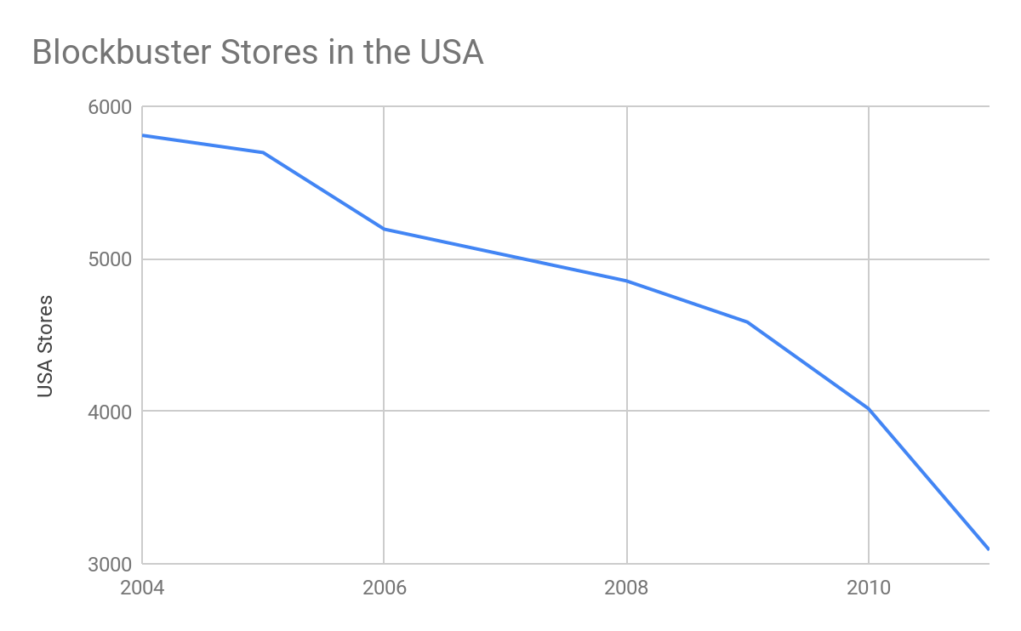

2.1.3 Dissonance With Shareholders
In 2004, Blockbuster’s owner, Viacom, granted the rental giant its independence citing an inability to integrate Blockbuster into its other media assets. John Antioco was now accountable only to a newly expanded host of shareholders who had, at first, little interest in contesting the leadership of the CEO who had brought Blockbuster to the height of its market dominance.
As part of being spun off into its own business, Blockbuster was granted a number of shares in Viacom. John Antioco promptly sold them off, and in that same year began an ambitious program of expansion into new markets and technologies. Carl Icahn, a billionaire activist shareholder, took up the position of leading those shareholders who were skeptical of the new strategy. By 2005, he’d begun an aggressive campaign to join the board of directors.
For Icahn, the changes Antioco was pushing for were too radical. By May of 2005, Icahn had been elected director of the board, alongside three allied candidates who were elected with 77% of the vote. A landslide victory for the skeptics proved that shareholders had little confidence in Antioco, but Icahn himself had unimaginative solutions to the same problems the CEO was trying to solve. Among Icahn’s criticisms of Antioco were allegedly wasteful initiatives to win customers back, and his decision to pull out of an attempt to buy out Blockbuster’s number two competitor in video rental, Hollywood Entertainment (a buyout that would have effectively saddled Blockbuster with more stores facing the same mounting obsolescence).
The fundamental problems facing Blockbuster had not changed, but Antioco’s attempted measures to solve them would face hostility from Blockbuster’s own leadership structure. Antioco would be forced to press on alone, and with greatly diminished resources.

2.1.4 Pushback From Within
With growing competition by Netflix and Redbox, Blockbuster attempted reforms but was unable to commit to them. This indecisiveness contributed to the company’s failure.
By 2004, John Antioco understood the threat posed by Netflix and that Blockbuster’s business model was unsustainable. He attempted drastic new changes that would take the company into a more competitive direction. These were the “No Late Fees” program and Blockbuster Total Access.
Antioco estimated a $400 million cost to these initiatives. In 2004, Blockbuster reported a $1.25 billion dollar loss in operating income, a 149% increase from the previous year. This proved to be too high a price for the board of directors. Led by Carl Icahn, they pushed for the reinstatement of late-fees and to refocus attention on brick-and-mortar stores.
Antioco was forced out in 2007 over the board’s complaints about his decision making and his annual bonus. The board engaged Jim Keyes, former president and CEO of 7-eleven, to replace him. Keyes’ new strategy returned brick-and-mortar stores to the centrepiece of Blockbuster’s business. They would revamp the stores by selling beverages, snacks, books and electronic gadgets. They would sell DVDs as well as renting them, competing with outlets such as Walmart. Antioco’s reforms were halted and eventually reversed. Blockbuster Total Access subscription fees were raised and the service lost half a million subscribers. In 2010, late-fees were reintroduced under the guise of an “additional daily rate”, which was capped at $10; cheaper than the old late-fees but still of lesser value than competitors’ monthly subscriptions.
As Keyes and Icahn refocused on the stores, they would publicly dismiss the competition by Netflix and Redbox, right up until Blockbuster filed for bankruptcy in September 2010.

2.2 Results
While the declaration of bankruptcy in 2010 would free Blockbuster from its multi-billion dollar debt, the damage was already done. Having lost critical market share, the company would change leadership and owners several more times over the following years. By then, value mostly came from attempts by other companies to use Blockbuster’s iconic branding to compete with Netflix as a streaming service. Eventually, Blockbuster’s final owners, the Dish Network, found no use in this purpose, and would combine Blockbuster on Demand and the Blockbuster@home TV package into the DISH movie pack. The Blockbuster brand now survives only in its final location in Bend, Oregon.
“In hindsight, there are things that could have been done differently. It was probably a mistake to sell Viacom’s 80% stake all at once—that’s a lot of stock for a market that hasn’t really been following the company. I probably should have met with Carl earlier, before the proxy fight, to lay out what we were doing and why. That might or might not have had an impact on his desire to hold on to the stock.”
~ John Antioco
“Blockbuster turned out to be the worst investment I ever made. It failed because of too much debt and changes in the industry. It had too many stores, Netflix created a better business model, and then Redbox kiosks and the whole digital phenomenon eliminated the need for consumers to go to a separate DVD store. Maybe the board did make a mistake in picking Jim Keyes as Antioco’s successor—Keyes knows retailing and did an excellent job with the stores, but he isn’t a digital guy. I also think Antioco did a good job in executing on Blockbuster’s Total Access program, which allowed customers to rent unlimited movies online and in stores. Over time it might have helped Blockbuster fend off Netflix. But Keyes felt the company couldn’t afford to keep losing so much money, so we pulled the plug. To this day I don’t know what would have happened if we’d avoided the big blowup over Antioco’s bonus and he’d continued growing Total Access. Things might have turned out differently.”
~ Carl Icahn

3.1 Discussion
Though Blockbuster was the uncontested leader of movie rental in its prime, it had risen to that station by punishing renters with late-fees. Whether or not this was smart or ethical is moot; consumers didn’t enjoy it, and when an alternative became available through Netflix, they began to switch over at a rate that Blockbuster never succeeded in halting.
Netflix gained the upper hand with a new way of providing an old service, while the proliferation of new technologies was something Blockbuster was slow to react to. Heavily invested in its brick-and-mortar stores, Blockbuster’s shareholders were fearful of abandoning their traditional model in favour of overhauling it to meet the challenges of the digital age.
Ultimately, the most important detail of Blockbuster’s failure was that it did, in fact, realize the threats to its dominance and attempt to take steps to rectify them. John Antioco made vigorous attempts to reform Blockbuster into something less antagonistic to customers and more convenient by way of technology, but he failed to ensure the shareholders would buy into these changes. Under Carl Icahn, Blockbuster’s leadership structure fought these changes wherever it could, before undoing them altogether. By the time they realized Antioco’s foresight, Blockbuster’s competitors had already grown too strong.

3.2 Recommendations
Based on the findings of this case study, the CRTC recommends that in order for Canadian broadcasting and telecommunications companies to remain competitive with American media services, they should:
- Be vigilant of and accommodating towards disruptive innovation, in techniques and technology.
- Ensure all major stakeholders in the business are appraised of the importance of change. Feuding between reformers and conservatives within a company can be fatal.
- Offer the Canadian consumer affordable, accessible and quality service.
- Communicate openly with the public and its stakeholders.
- Collaborate with stakeholders in business decisions.

4.1 References
Antioco, John. April 2011.
https://hbr.org/2011/04/how-i-did-it-blockbusters-former-ceo-on-sparring-with-an-activist-shareholder
Bachega, Hugo. August 16, 2018.
https://www.bbc.com/news/world-us-canada-45175194
Berr, Jonathan. May 12, 2005.
https://www.nysun.com/business/carl-icahn-wins-seat-on-blockbusters-board/13719/
Bertoni, Steven. March 21, 2011.
https://www.forbes.com/sites/stevenbertoni/2011/03/21/billionaire-carl-icahn-calls-blockbuster-his-worst-investment-ever/#41b67c3b38d6
Blockbuster’s archived 10k annual reports. Morningstar.com
https://doc.morningstar.com/companydoc.aspx?doccategory=equity&mode=normalview&companyid=0C000006Y8&display=%3ABLOKA&clientid=dotcom&key=9bc0dc0ff19106fc&%23&GDLTab=Financials###
Carr, Austin. September 22, 2010.
https://www.fastcompany.com/1690654/blockbuster-bankruptcy-decade-decline
Chhabria, Ashwin. March 23, 2017.
https://medium.com/@ScAshwin/the-rise-of-netflix-and-the-fall-of-blockbuster-29e5457339b7
Deshpande, Amit. 2011.
http://amitadeshpande.blogspot.com/2010/12/netflix-vs-blockbuster.html
Encyclopedia.com. Last edited 29 January, 2019.
https://www.encyclopedia.com/social-sciences-and-law/economics-business-and-labor/businesses-and-occupations/blockbuster-inc
Epstein, Edward Jay. January 9, 2006.
https://slate.com/culture/2006/01/the-last-days-of-blockbuster.html
Frankel, Daniel. April 23, 2007.
https://variety.com/2007/digital/features/dvd-timeline-1117963613/
Graser, Marc. November 12, 2013.
https://variety.com/2013/biz/news/epic-fail-how-blockbuster-could-have-owned-netflix-1200823443/
Laurent, Allie. June 12, 2017.
https://channels.theinnovationenterprise.com/articles/classic-strategic-failures-blockbuster
NBC News. March 30, 2005.
http://www.nbcnews.com/id/7327309/ns/business-us_business/t/blockbuster-settles-no-late-fees-claims/
NBC News. September 23, 2010.
http://www.nbcnews.com/id/39332696/#.UsR2K_RDv9c
Newman, Rick. September 23, 2010.
https://money.usnews.com/money/blogs/flowchart/2010/09/23/how-netflix-and-blockbuster-killed-blockbuster
Sanders, Monica. December 2009.
https://www.legalzoom.com/articles/why-is-netflix-suing-blockbuster
Satell, Greg. September 5, 2014.
https://www.forbes.com/sites/gregsatell/2014/09/05/a-look-back-at-why-blockbuster-really-failed-and-why-it-didnt-have-to/#693c98701d64
Sciretta, Peter. March 2, 2010.
https://www.slashfilm.com/blockbuster-brings-back-late-fees/
Zeidler, Sue. November 27, 2007.
https://www.reuters.com/article/us-media-summit-blockbuster/blockbuster-says-may-add-stores-idUSN2751139220071128

