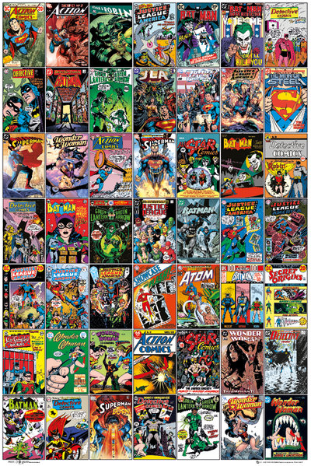

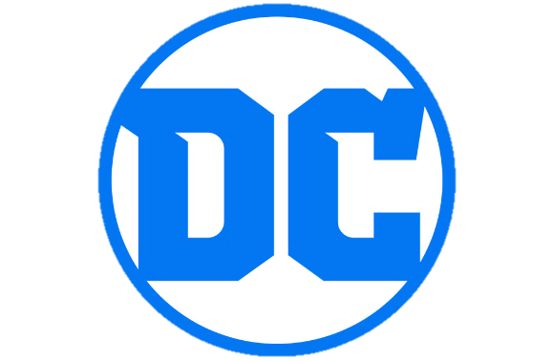

WONDER WOMEN!

How prominent are women in DC Comics?

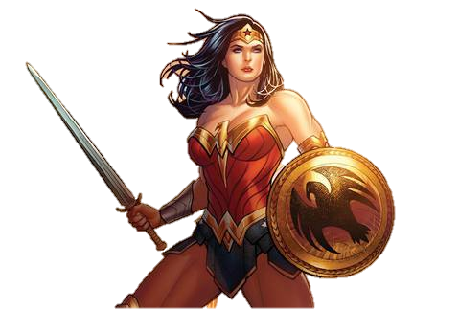
“Why study this?”

We live in an era where media and entertainment are increasingly scrutinized for their representation of women and minorities, and DC would be wise to scrutinize itself along those lines before someone else can. People of all political alignments are scouring the internet for the next big thing to be outraged about – it pays to check you don’t have a target on your back.
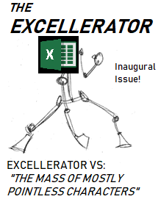
Even evaluated from a less cynical standpoint, a critical lack of women in DC Comics is reasonably bound to lead to a critical lack of women reading DC Comics. With women comprising roughly half of the North American population, this is a large potential audience to be missing out on.

The Wiki Data
All data for this report has been compiled in a table harvested from a dedicated wiki, tended to and jealously guarded by comic book fans and chronicling all characters since DC’s founding to 2012. It contains DC and Marvel characters alike, and the latter will see use for purposes of comparison.
Why that’s good: The data is incredibly immaculate in its accuracy and detail, with nothing left out for fear of irrelevance. It would be difficult to assemble a roster of characters better suited to a study such as this.
Why that’s bad: The data is incredibly immaculate in its accuracy and detail, with nothing left out no matter how irrelevant. It would be difficult to assemble a roster of characters better suited to skewing the results of a study such as this.
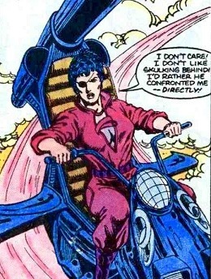
Remember Bazooka Joan? Remember those four panels of the one Firestorm issue she showed up in? This wiki does.
It’s important to note that the presence of many largely insignificant characters in the data is only detrimental to some forms of analysis and not others. When checking the DC universe for female representation, it is valid to verify how many one-issue villains and minor characters are female as well. The inclusion of all the heroic and villainous D-listers can skew some specific analyses, but not in a way that can’t be circumvented.

Primary Analysis

With all male and female characters included, we see that DC Comics manages 1967 female ones and 4783 male ones – 29% of the combined roster is female. While far from the 50% needed to reflect the real-life population of North America, is 29% a decent figure in its own right? To gain a sense of perspective, why not compare that figure to that of DC’s eternal competitor, Marvel?

Subjecting the Marvel data to the same graph and analysis shows that DC carries the advantage. With 3837 out of 15475 characters total being female, only 24.7% of Marvel’s universe is female. While both comic universes have a ways to go before achieving the 50% mark, DC is closer to it.
Let’s examine the women of the DC universe more closely.

For the purposes of this particular analysis, the extremely small category of “Reformed Criminals” in the dataset was counted among the heroes, and “Neutral” characters were not included. As we can see, DC seems to have preferred women in heroic roles: 34% of heroes are female, as opposed to 21% of villains. For the most part, this is a culturally “safe” finding. While DC should strive for greater female representation among the forces of evil, inflammatory cultural critics would love “DC Comics Females More Often Evil Than Good” as a headline. Thankfully, such a headline would be false.

Now we begin to cut the chaff from the dataset, and at the same time begin to find its limits. While the data is cluttered with a great many bit characters from the foundational eras of comics, it is well worth looking at the “modern” DC and its response to the relatively new demand for greater female and minority representation in media. Looking at characters who debuted exclusively during 2008 and later, we can see that DC has mostly stayed the course; just shy of 32% of all characters created during this time were female. If DC reacted to this cultural shift, it wasn’t by noticeably changing the number of female characters. Before we assume there was no reaction…

Let’s check how many issues of comic books those new characters made appearances in. By this metric, female representation has risen to nearly 36%, which is especially notable when we note one of the hurdles to this post-2008 examination: with the data ending in 2012, this is effectively changes over a four-year period. Given the 5% increase in four years from an average derived from 1936 until 2012, we can assume that this trend of female representation has increased in the past seven years.


The rate of appearances is also an excellent metric for separating major characters from the Bazooka Joans. Cutting out all characters with fewer than 517 appearances (the exact number the Joker has), we limit the roster to an “all star” lineup of iconic characters. Disappointingly, a mere five of the 28 characters are female, and one of them is Lois Lane. While Superman’s classic love interest has had her role and abilities in the DC universe increased dramatically since the character’s inception, she still remains an icon of the much-reviled “damsel in distress” trope. An unsurprising name to find among these five is Wonder Woman, who also has the sixth overall most appearances in DC Comics. She beats out Aquaman, the Flash, and Alfred Pennyworth for this distinction.

Further Analysis
But, now that we know how prominent women are in DC Comics, it’s worth asking if there’s a wisdom in DC’s seemingly slow pace of change. How important is the demand for female and minority representation to comics? Is this manifesting in DC’s business, or is this just a cultural zeitgeist with no impact on sales?

To answer this, we turn to the invaluable resource that is comichron.com and the piles of data stored there. As comics stores are independent businesses in their own right, research into how much of a given comic run should be ordered can make or break their financial wellbeing – Comichron is consequently an intuitive site with very detailed records, and even analysis of its own.

To get a good sense of how huge the demand for female representation is impacting DC Comics, let’s look at the sales of the main Wonder Woman comic every January from 2008 to 2019. Immediately, what stands out about these numbers is their consistency - with only a few outliers, Wonder Woman’s sales have been very steady.
  - Outlier Analysis
- The dip in 2010 is on account of DC Comics’ successful Blackest Night event, wherein a Blackest Night: Wonder Woman comic was being run at the same time as the main Wonder Woman comic (the former sold very well).
- The spike in 2012 sales can be attributed to DC’s extremely strong showing in that month, with Wonder Woman managing to take #16 in units sold and Justice League leaping all the way to #1.
- Wonder Woman also sold very well throughout much of 2017 owing to the release of the Wonder Woman movie in that year.
In addition to a mean average of 38,532 comic books, Wonder Woman has consistently hovered in the low thirties for overall ranking of units sold. That this number has neither risen nor fallen in any considerable amount even in the wake of the Wonder Woman movie points to a deeper truth of the DC consumer base: steady numbers can only be provided by steady customers, who purchase Wonder Woman routinely. The core audience of Wonder Woman has not meaningfully expanded or contracted even as culture wars engulf the internet, meaning that the women of today either look to different heroines for inspiration, or more likely look beyond comics altogether. In either case, DC understandably feels neither incentive nor pressure to change the formula of its characters and universe.

Conclusion
DC Comics is gradually responding to the demand for a more inclusive comics universe – the promotion of Cyborg (one of DC Comics’ few black characters) from a minor player to a full-blown member of the Justice League is proof of this. Far as the prominence of women in DC Comics is concerned, they are underrepresented, but still have big and well-known names like Diana Prince. While more female characters are being introduced with the progression of the 2010s, that progress is still very slow.
With a verifiable lack of impact on sales, it’s easy to see why this is. Wonder Woman is proof that the outcry for more women in comics isn’t translating into higher sales for the original “woman in comics,” and DC can comfortably ignore this issue in favour of focusing on whatever it deems to be a more pressing matter - presumably its cinematic franchise.
It is very important to remember that for all the iconic characters and intellectual properties they have given us, comics are a dying medium. The combined sales of all comic books in 2017 sold for approximately 522 million, while the Wonder Woman movie released in that same year grossed for 821 million worldwide. It’s entirely probable that DC is very concerned about female and minority representation in its universe – albeit the universe depicted in theatres, where the money is. For comics, DC feels no need to rock a sinking boat.


Because no clickbait website would lie in a headline, right? Right?
Seriously. She has psychic powers now.
This is actually impressive when you remember Batman is by far the highest-selling of all DC Comics.
Effectively hailed by critics as “the one non-garbage DC universe movie.”
That’s Wonder Woman.

